Continuous Delivery for Docker Containers

Flow of this project
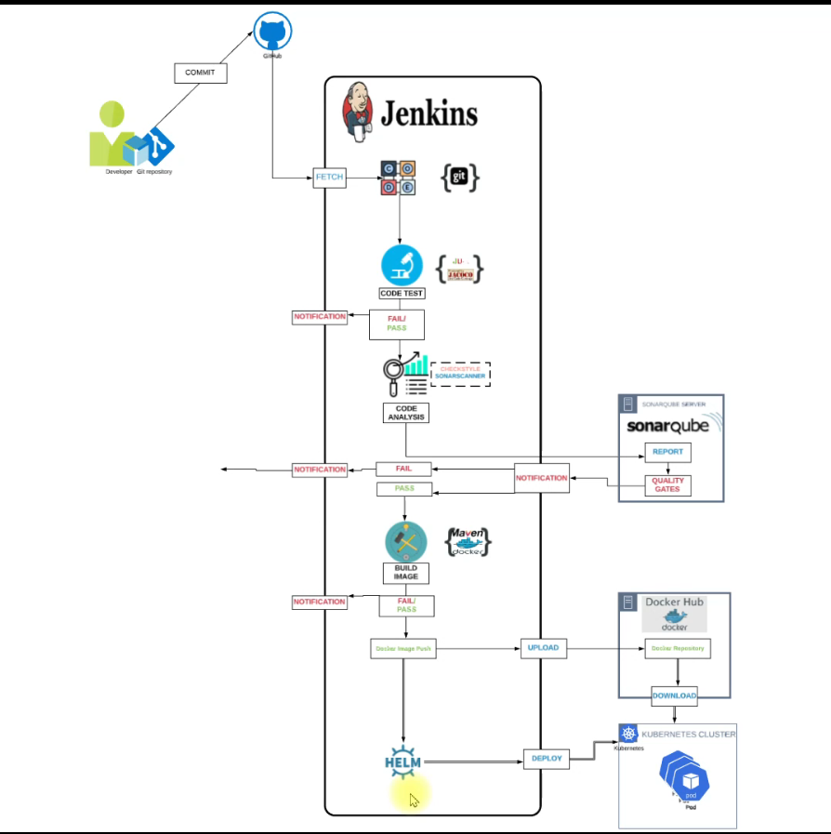

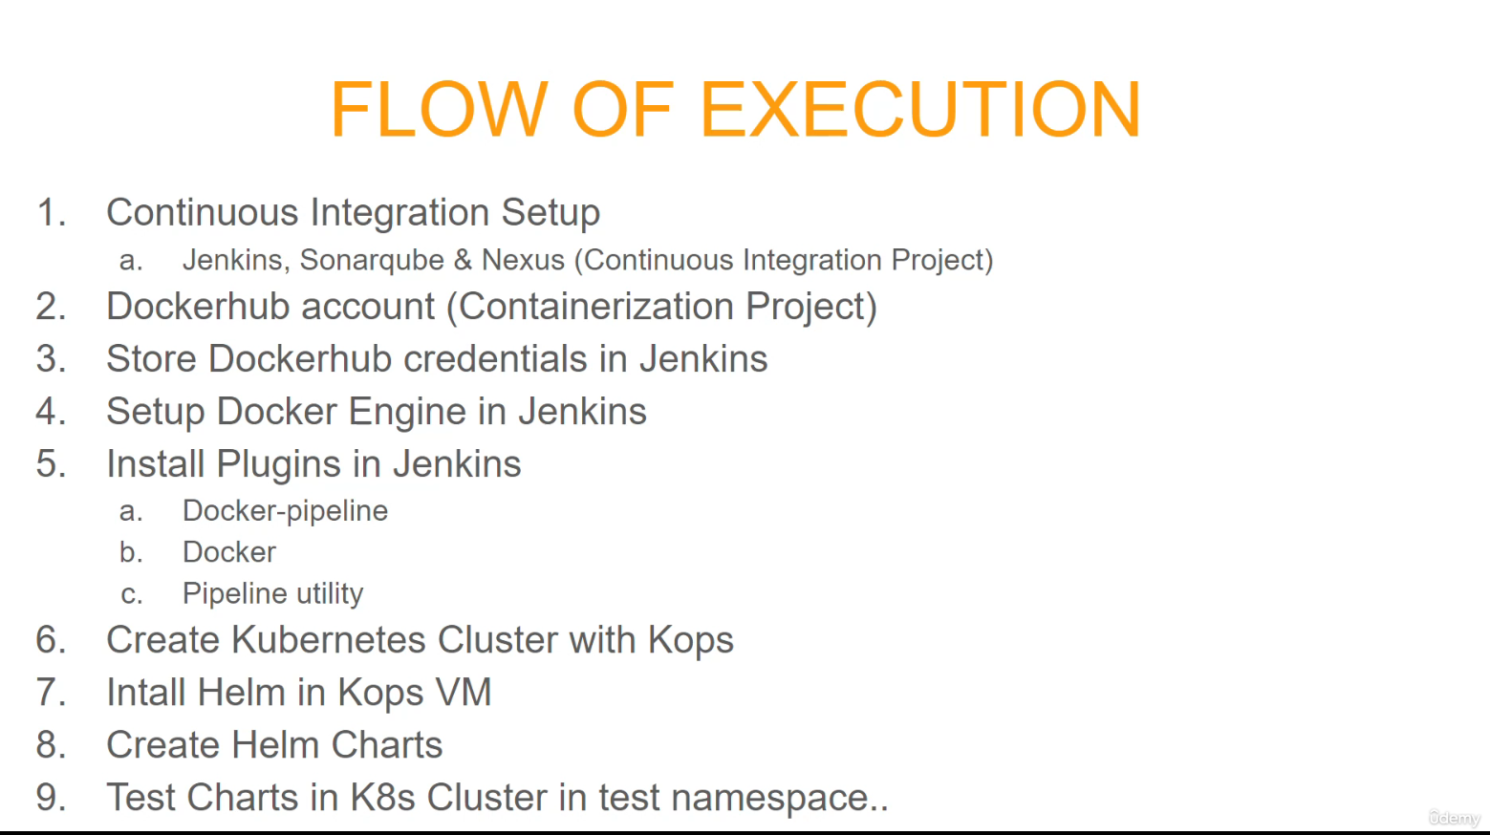
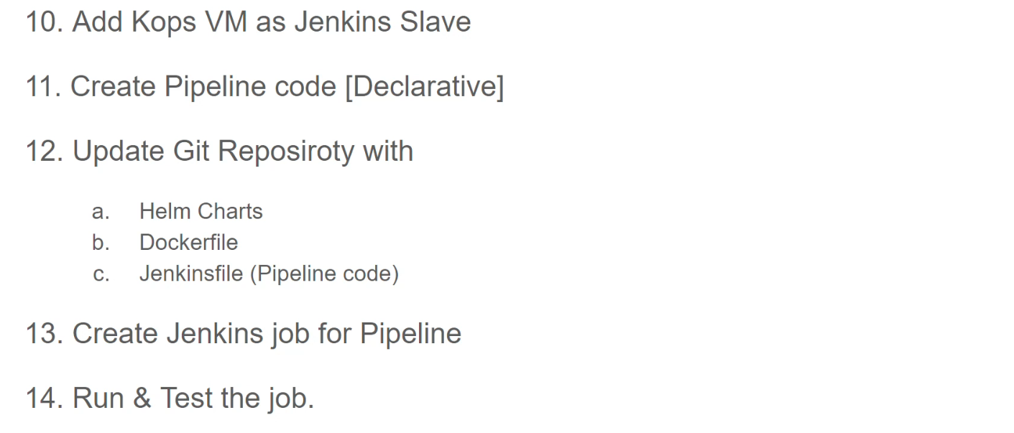

Step 1 Make ready Sonar Qube setup, Kubernetes using Kops vm , and Jenkins- Server
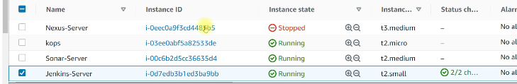

First We Ready Jenkins Sv

Open Ec2 Instance and give name Jenkins-Server and create keypair set t2 medium and create Security group i.e Jenkins-sg and make sure Ubuntu os you select

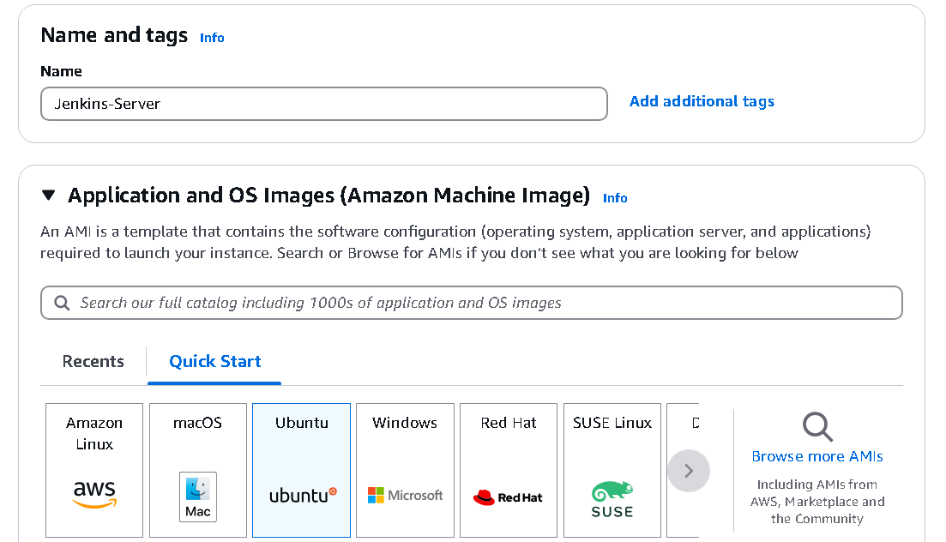

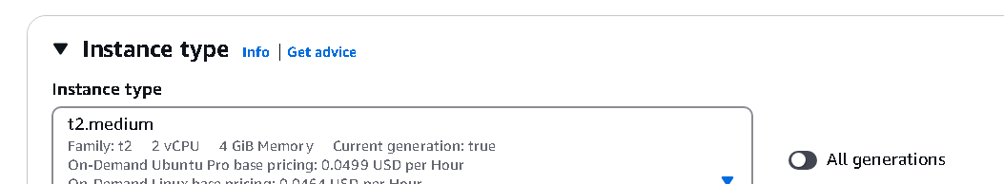
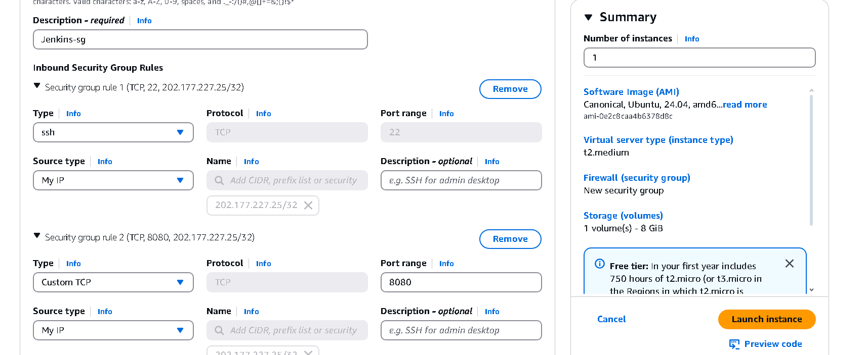

sudo apt update
sudo apt install openjdk-21-jdk -y

sudo wget -O /usr/share/keyrings/jenkins-keyring.asc \
https://pkg.jenkins.io/debian-stable/jenkins.io-2023.key

echo "deb [signed-by=/usr/share/keyrings/jenkins-keyring.asc]" \
https://pkg.jenkins.io/debian-stable binary/ | sudo tee \
/etc/apt/sources.list.d/jenkins.list > /dev/null

sudo apt-get update
sudo apt-get install jenkins -y
systemctl status jenkins
sudo cat /var/lib/jenkins/secrets/initialAdminPassword

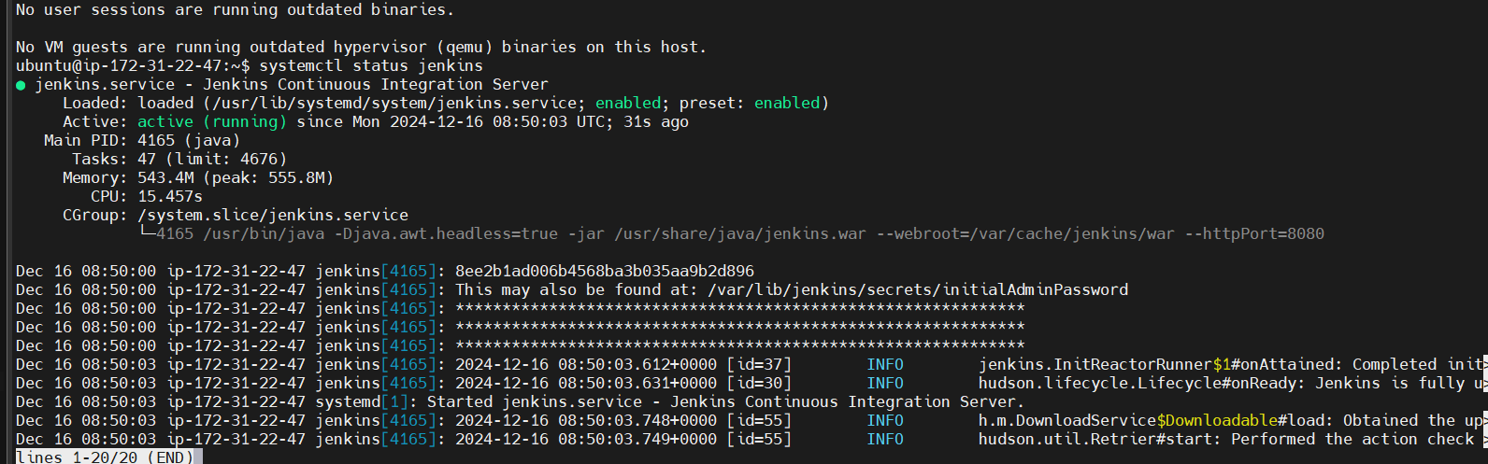

Now Create Sonar Server Ready on Ubuntu EC2 instance we required sonar.sh script file
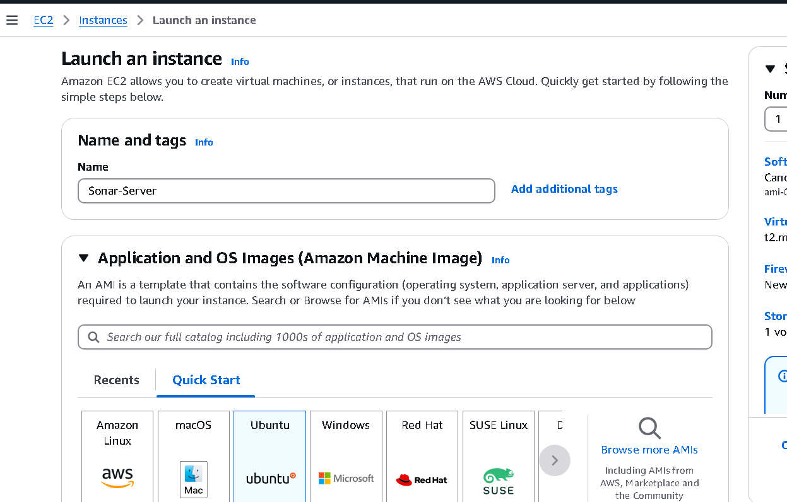
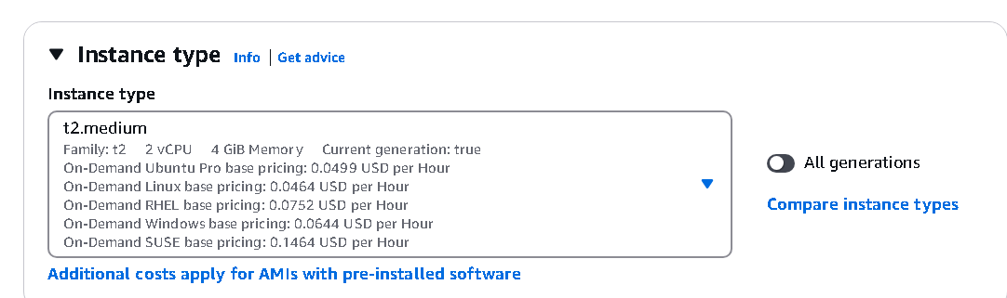

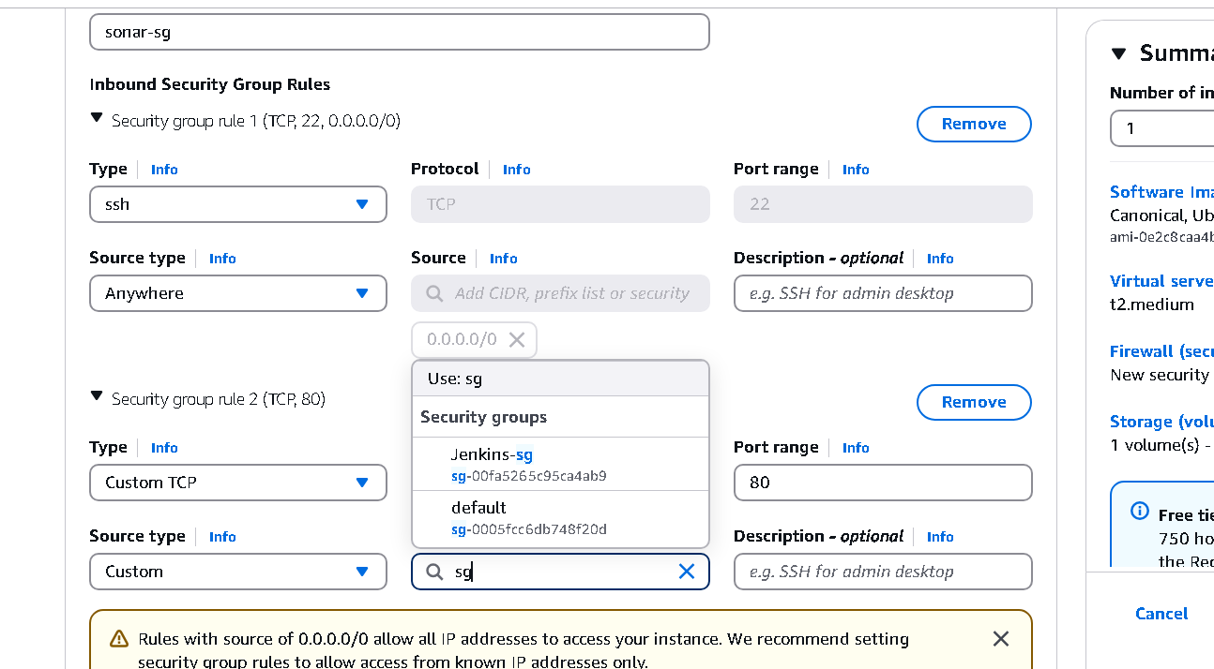

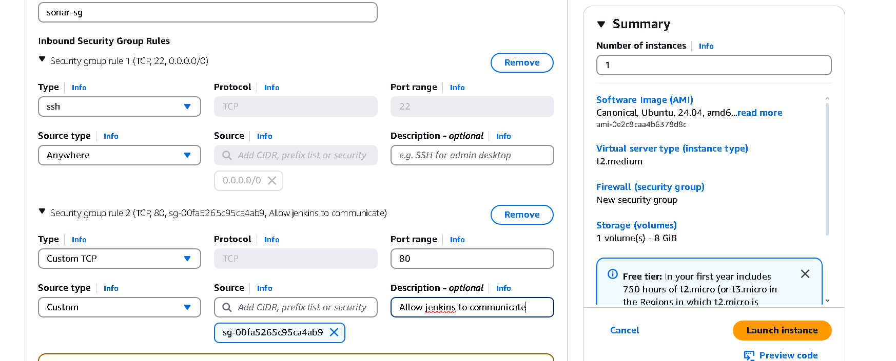

Now add Sonar script in UserData
https://github.com/Abhijeet41/vprofile-project-aws/blob/atom/userdata/sonar-setup.sh

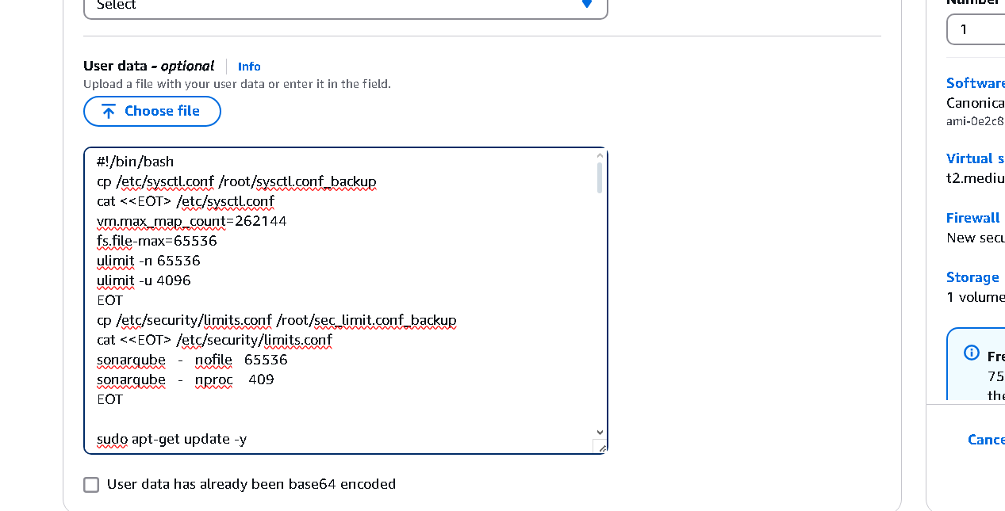

Above step will not work so install script manully login to ec2 instance using mobaxterm
vim sonar_script.sh
Paste all the content from github
$ chmod +x sonar_script.sh
$ sudo ./sonar_script.sh

Ok now copy public ip of ec2 instance and paste it on browser with port 80 because sonar hosted on nginx sv
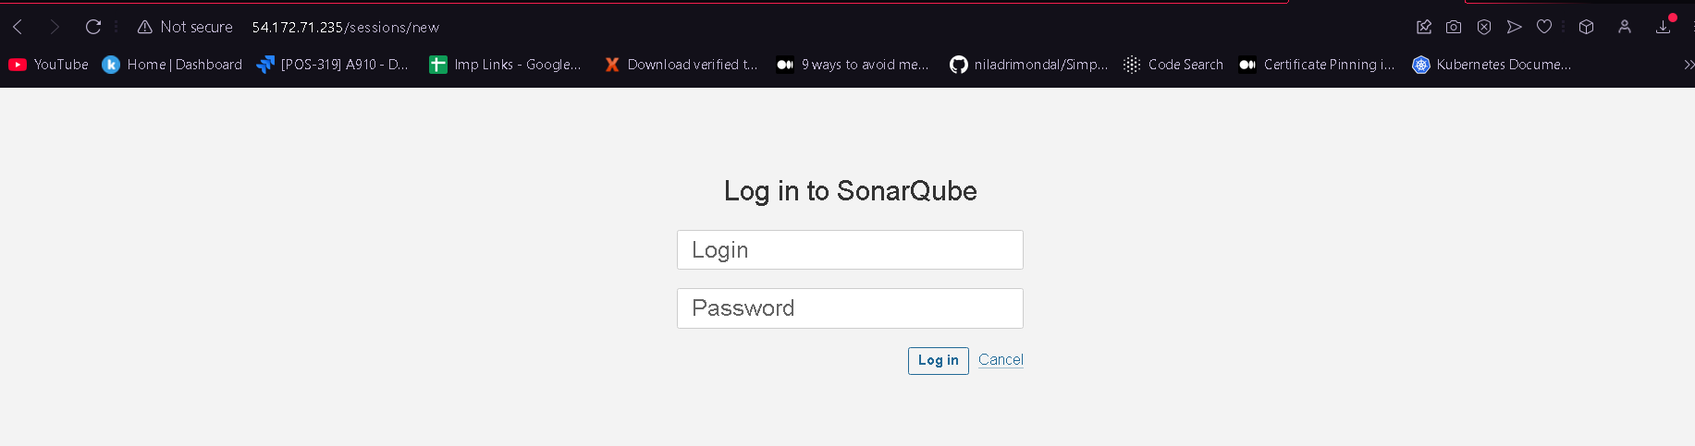

By default loginid and password is admin after login you will get changes password option I set password admin123

Now navigate administrator and click on my account and generate token

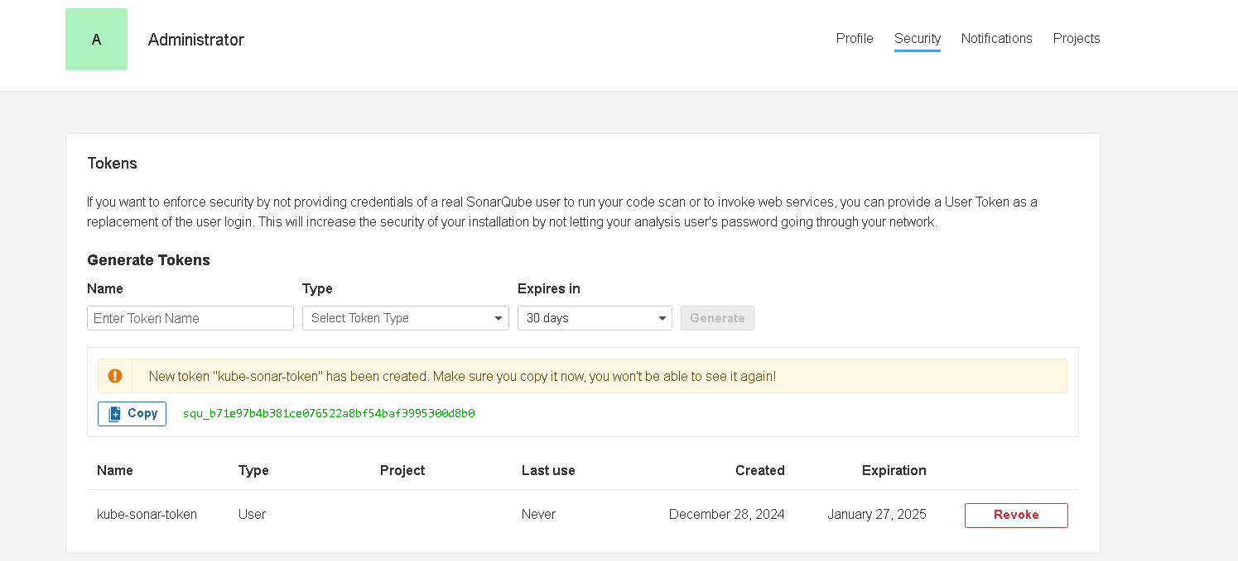
In Jenkins manage Jenkins-> System-> add sonar enviroment

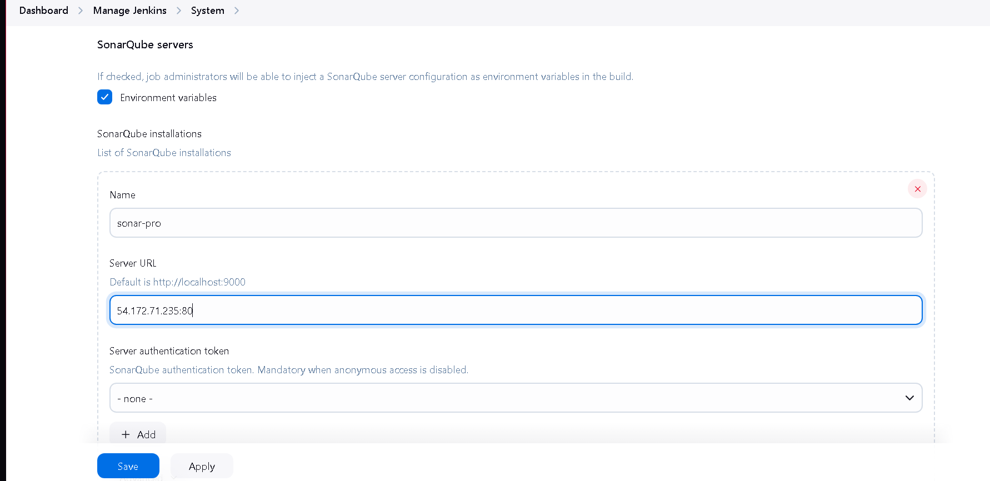
Add token here
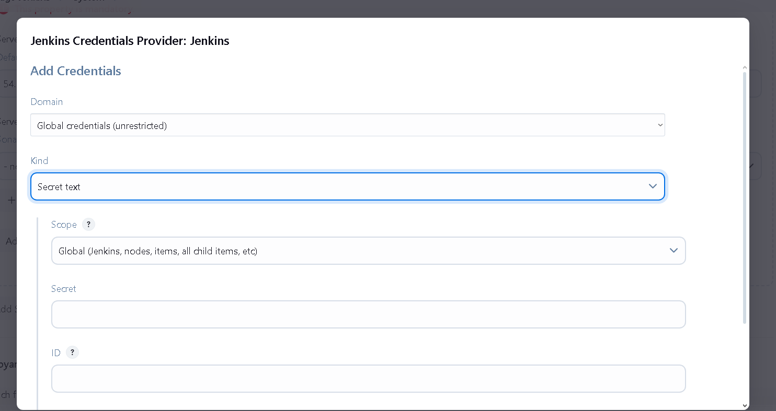

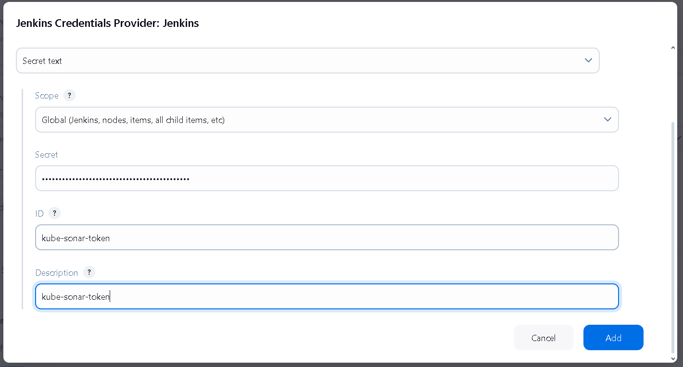

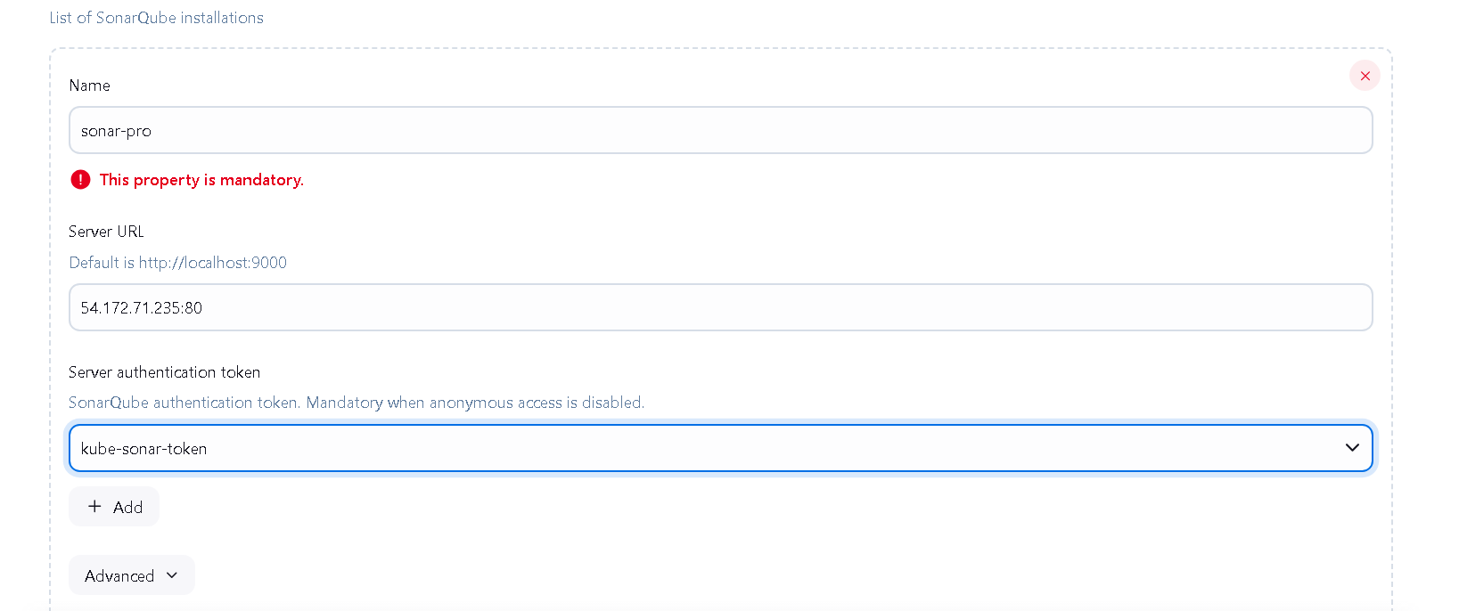
Now in manage Jenkins -> Tools -> add tool name or build name for sonar
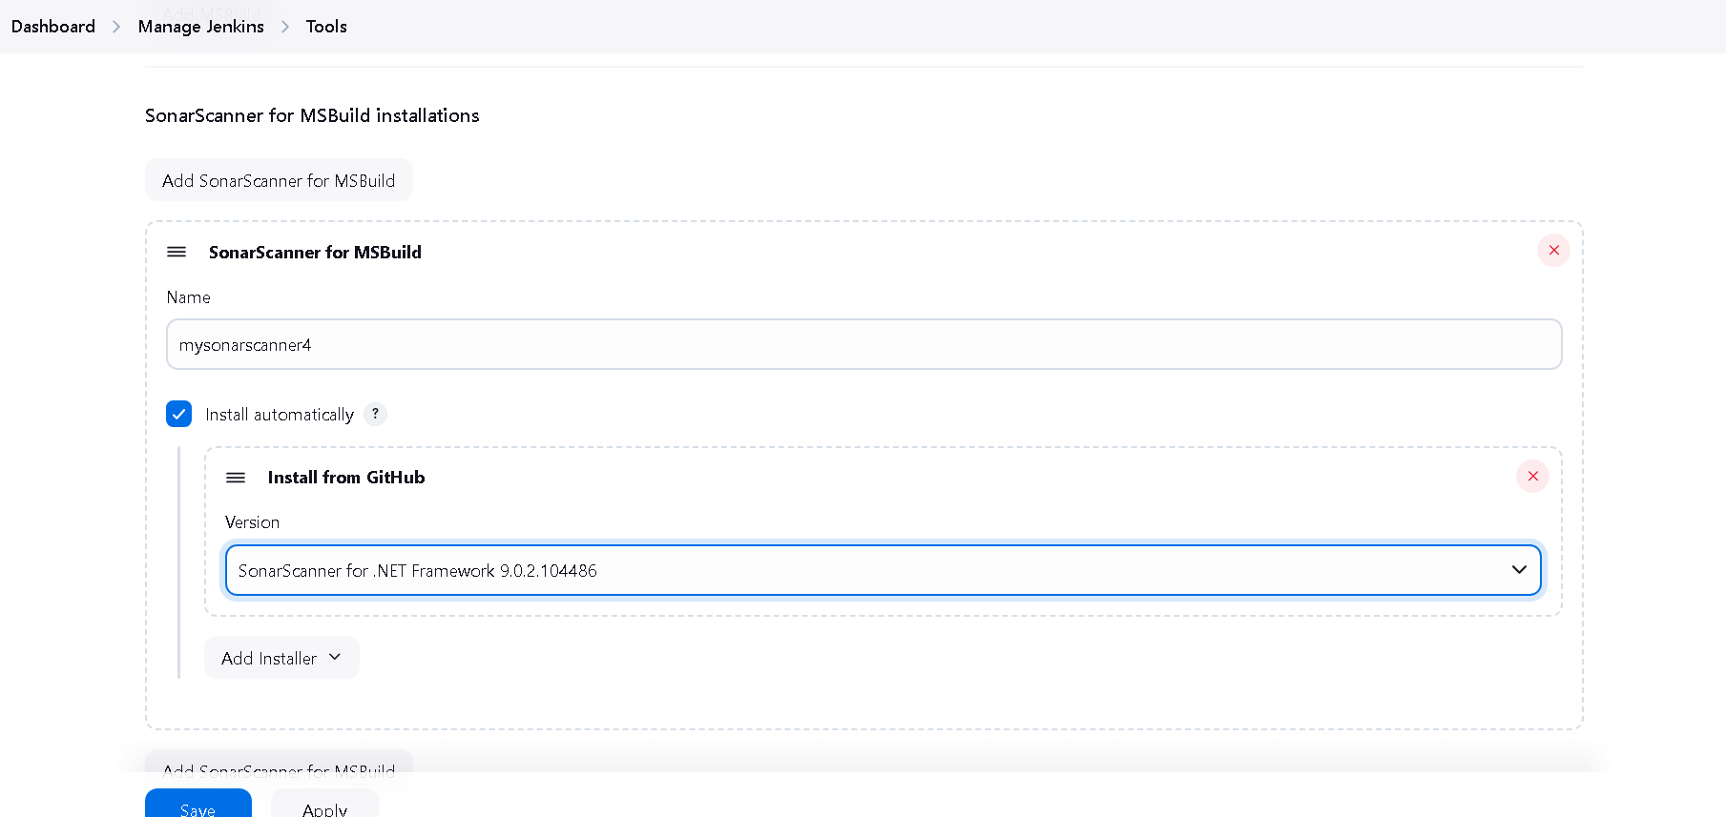

OHK Sonar Setup is Done Now Add Docker Hub Credential Details in Jenkins for that go to Manage Jenkins > Credentials > System and now click on Global credentials
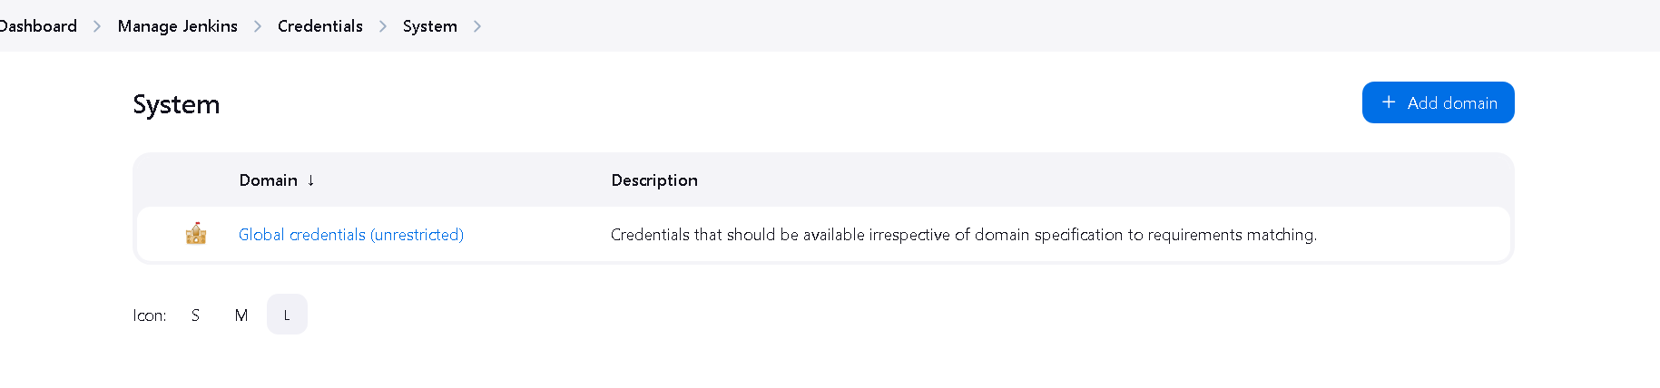
Now here add credentials
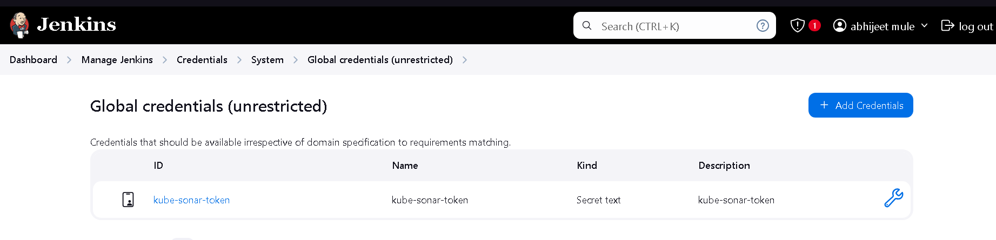

Here add username of docker hub username and password and user id that we use in jeknins script and description
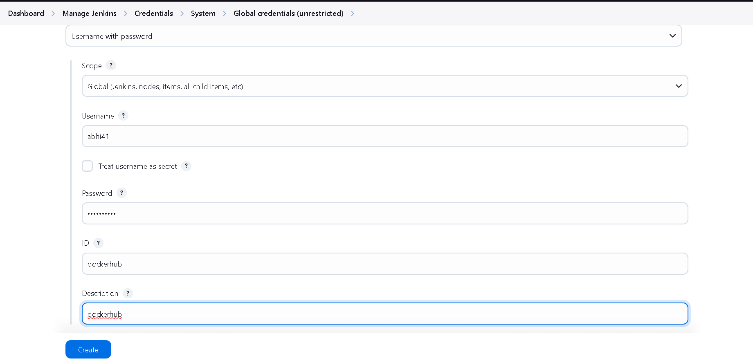

Next step is install docker engine in Jenkins Server here are following setps
sudo apt-get update
sudo apt install apt-transport-https ca-certificates curl software-properties-common
curl -fsSL https://download.docker.com/linux/ubuntu/gpg | sudo apt-key add -
sudo add-apt-repository "deb [arch=amd64] https://download.docker.com/linux/ubuntu focal stable"
apt-cache policy docker-ce
sudo apt install docker-ce
sudo systemctl status docker
sudo usermod -aG docker ${USER}
Now when you login to Jenkins user and try to run docker command the you will get error
sudo usermod -aG docker jenkins
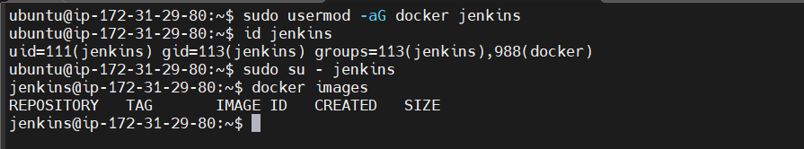
Now you can access docker command on Jenkins user
Make sure you installed docker plugin and docker pipeline plugin in Jenkins
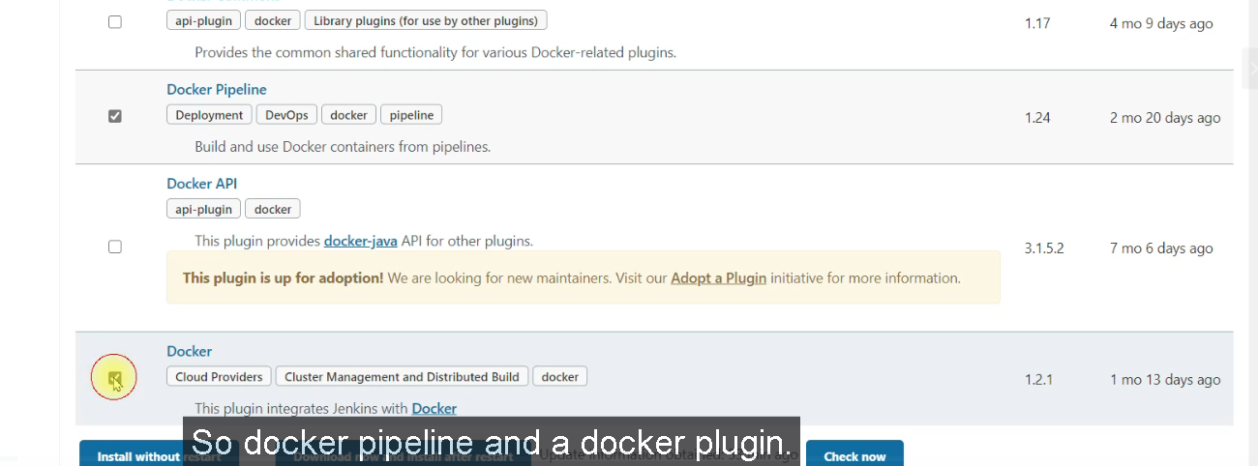
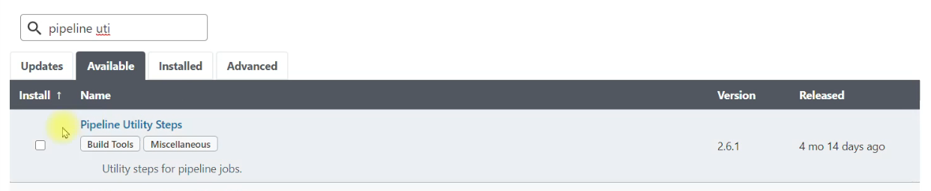
Now login to kops ec2 instance
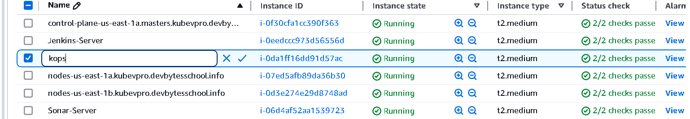
Validate your cluster make sure its up and running
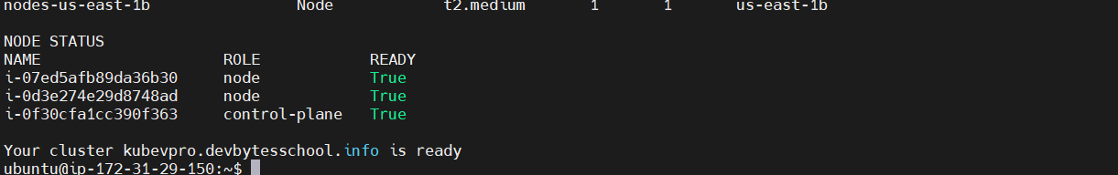

Now install helm in Ubuntu currently there is no helm plugin in Jenkins so we are going to add kops ec2 instance as a slave to
Jenkins and we’ll run helm command from kops vm itself
Helm is basically a packaging system for definition files we can package all the definitions for our project stack and we can also
deploy to kubernetes cluster. So instead of managing all the definition file for deployment, service, volumes all different definition files we maintain and manage separately, instead of that we can use Helm to package all of them and run them or update them on kubernetes cluster.

Vistin to https://helm.sh for installation
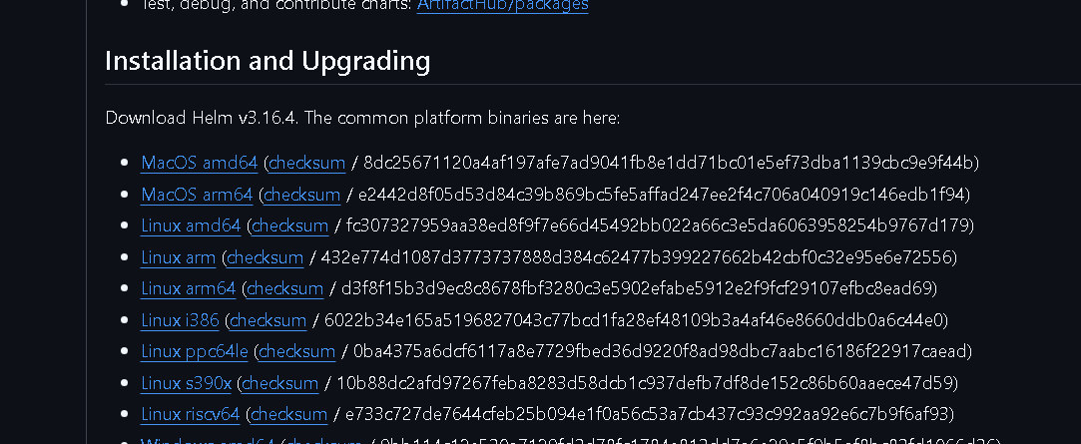
Click on Linux amd64 and copy link
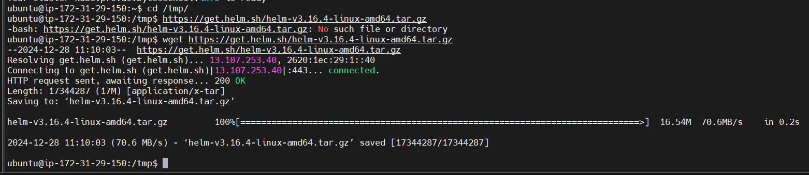
tar xzvf helm-v3.16.4-linux-amd64.tar.gz
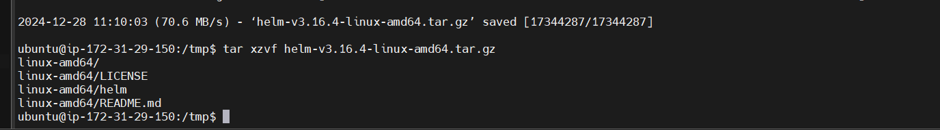
$ tar xzvf helm-v3.16.4-linux-amd64.tar.gz
ubuntu@ip-172-31-29-150:/tmp$ cd linux-amd64/
ubuntu@ip-172-31-29-150:/tmp/linux-amd64$ ls
LICENSE README.md helm
ubuntu@ip-172-31-29-150:/tmp/linux-amd64$ sudo mv helm /usr/local/bin/helm

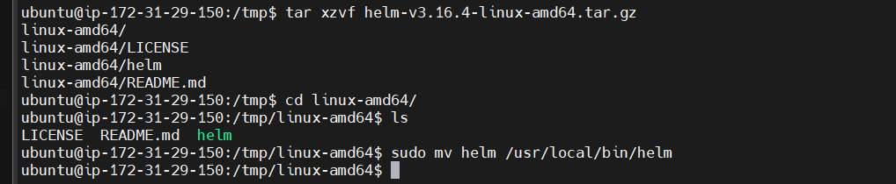
Helm is successfully installed
Now pull cicd pipeline project from github and create helm directory
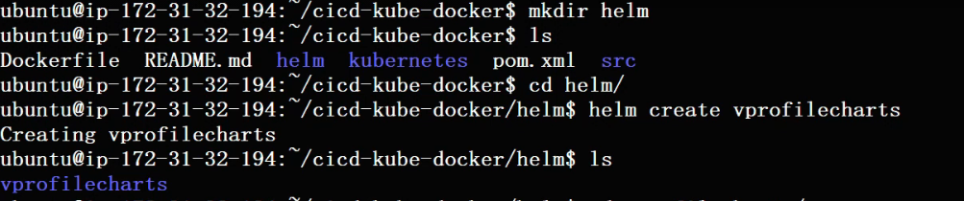
Here we can see vprofilecharts directory gets created and navigate to template directory and delete all sample data from it
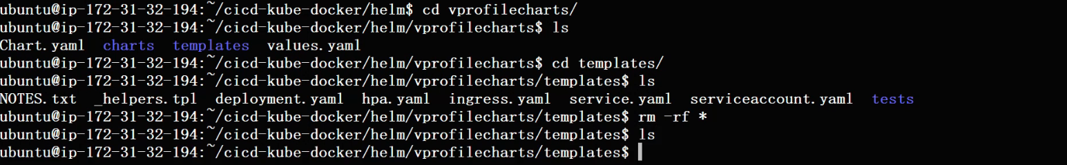
Now in template we should deploy our definition files
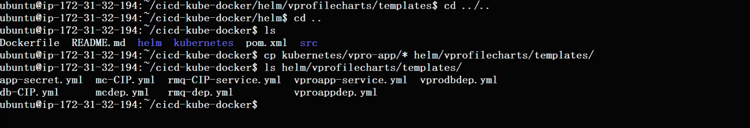

Now we need to do some changes in application deployment file because here we define our image like tomcat application that we regularly building, editing and deploying, so there cannot be a static value. We need to give variable over here which will pass automatically through Jenkins
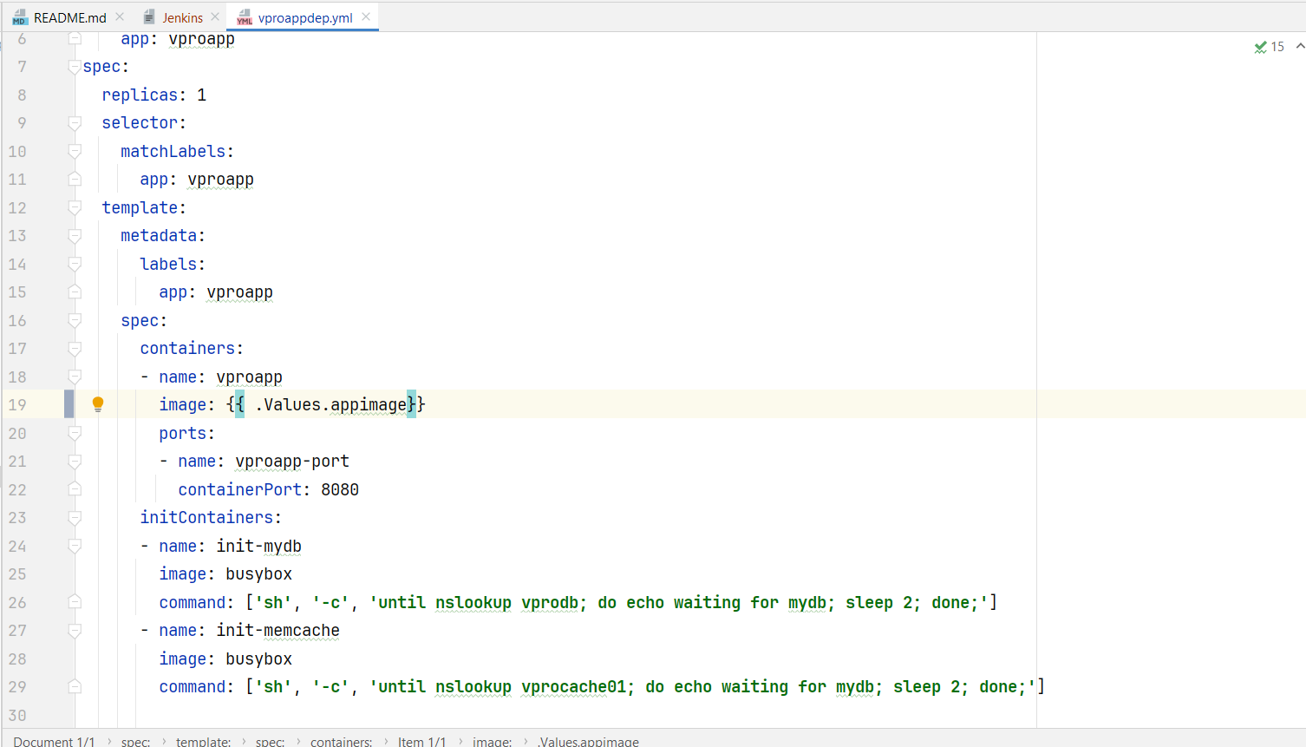

Now create namespace test to check helm command is working or not
$ kubectl create namespace test

$ helm install --namespace test vprofile-stack helm/vprofilecharts --set appimage=abhi41/vprofileapp:latest
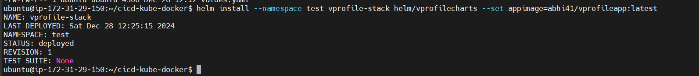
If check all nodes use below command
$ helm list --namespace test
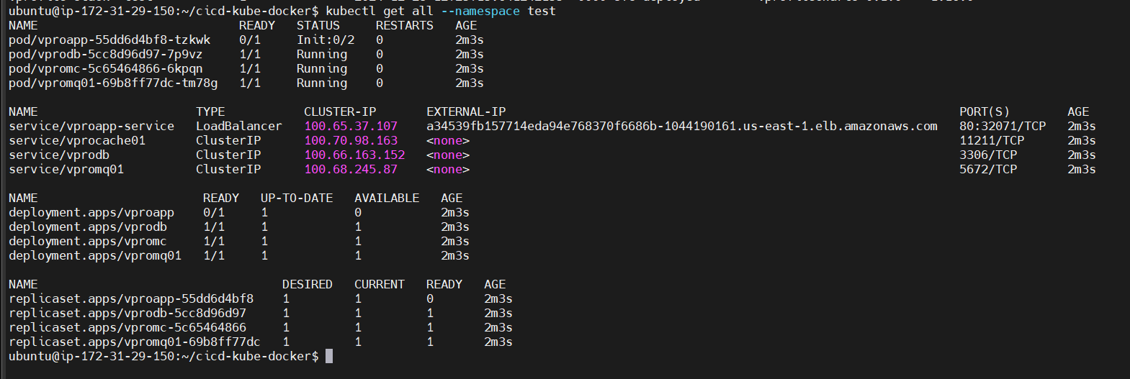

We all this do for testing purpose weather helm is working properly or not so delete this helm chart because we are going to do this all using cicd pipeline
$ helm delete vprofile-stack --namespace test
Now create 1 more namespace as prod
$ kubectl create namespace prod
now clone file from github and download in windows system and open in android studio and create new file Jenkins in project root directory and copy paste code from previous cicd project and remove all nexus related contet and add some new one
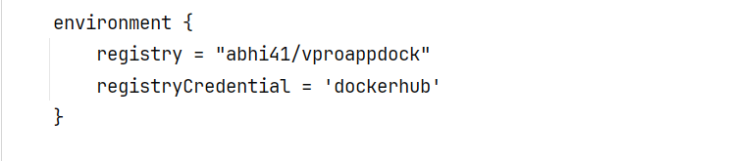

In above pic we define 2 variables registry for create new registry in docker hub account and registrtCredential for docker hub accound details that we defined in Jenkins our outh key name as ‘dockerhub’
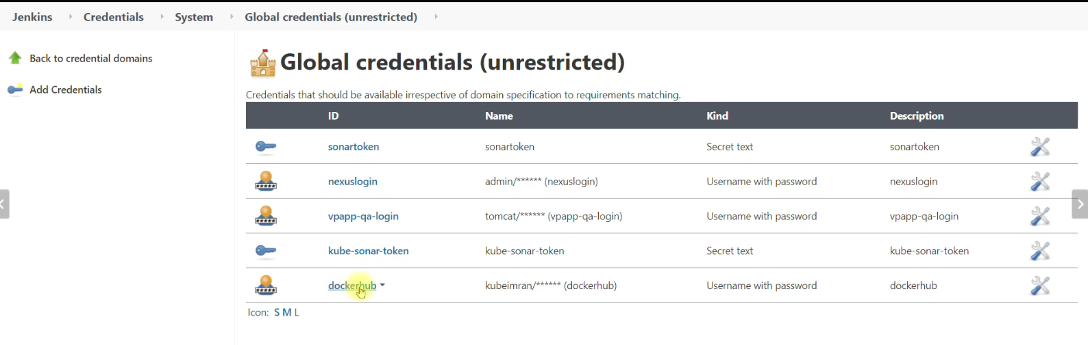

Add this below stages in Jenkins file below sonarqube stages
#build our docker image
stage('Build App Image'){
steps {
script {
dockerImage = docker.build registry + ":V${BUILD_NUMBER}"
}
}
}
#upload docker image to docker hub
stage('Upload Image'){
steps{
script {
docker.withRegistry('', registryCredential) {
dockerImage.push ("V$BUILD_NUMBER")
dockerImage.push ('latest')
}
}
}
}
#remove docker image
stage('Remove Unsued docker image'){
steps{
sh "docker rmi $registry:V$BUILD_NUMBER"
}
}

next stage is deploying image to kubernetes cluser and we are going to run helm command from kops. So we have to add kops ec2 instace as a slave to Jenkins so we will do that first before we edit jenkin file
open Jenkins and login into the kops ec2 instace remember not to worker nodes or master node we create kops cluser from that instace i.e kops // instance name
Install jdk 21
$ sudo apt install openjdk-21-jdk -y
Now make directory in opt folder
$ sudo mkdir /opt/jenkins-slave
$ sudo chown ubuntu:ubuntu /opt/jenkins-slave -R
We are going to use SSH from Jenkins to login to this kops ec2 instance with Ubuntu user so Ubuntu user should own this /opt/jenkins-slave directory

Now edit kops security group because Jenkins is going to do ssh to this kops instance that why we should allow Jenkins sv traffic in kops ec2
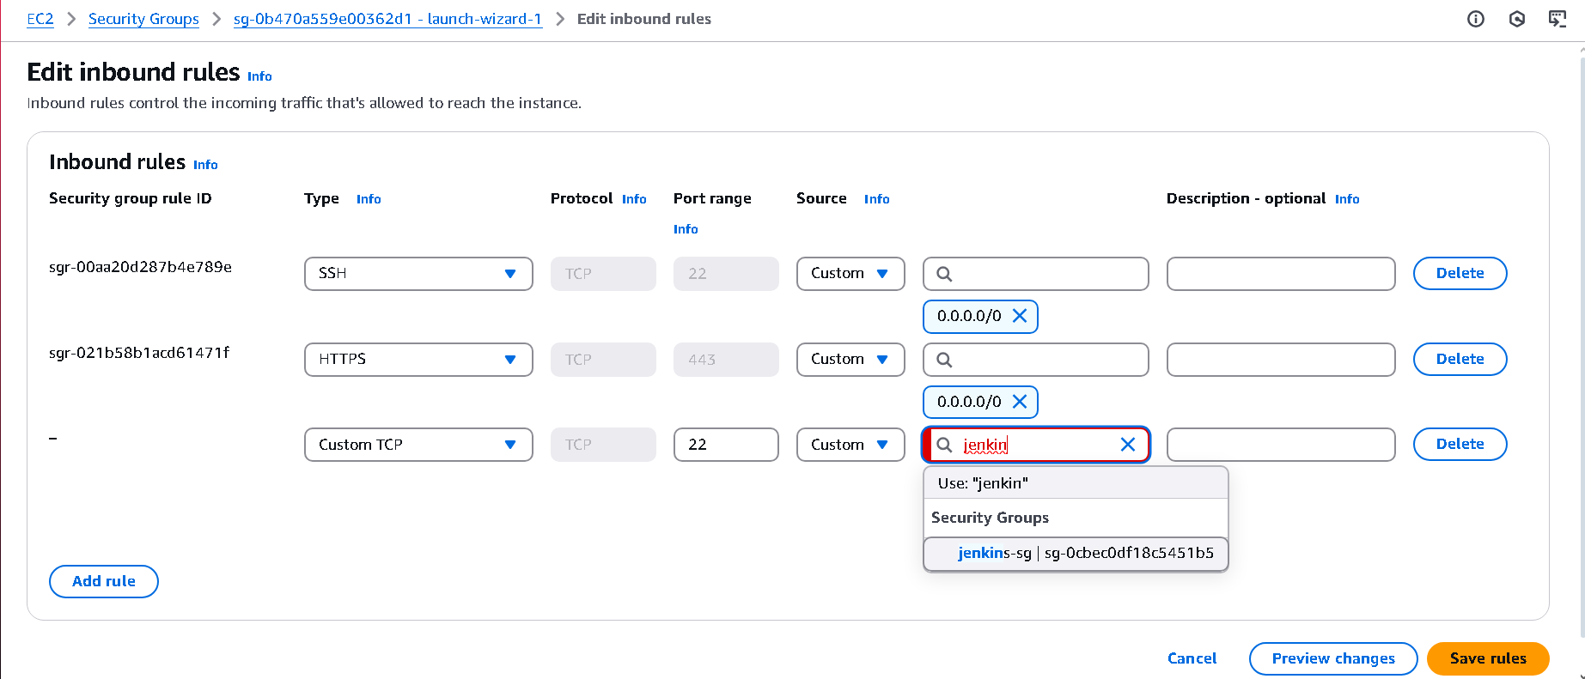
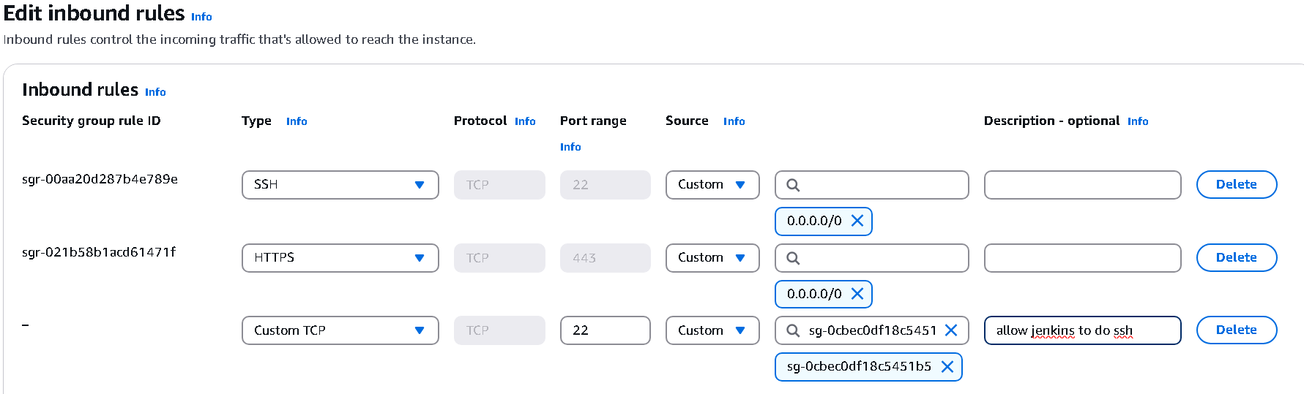

Now Open Jenkins and add kops ec2 instance as a slave
Manage Jenkins -> Nodes
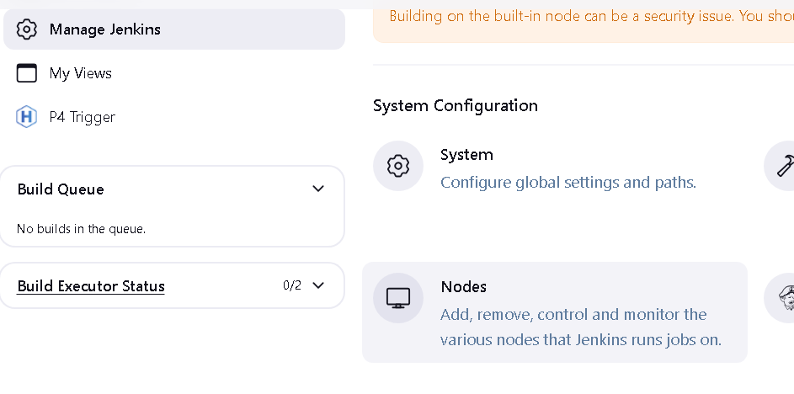

Click on new node
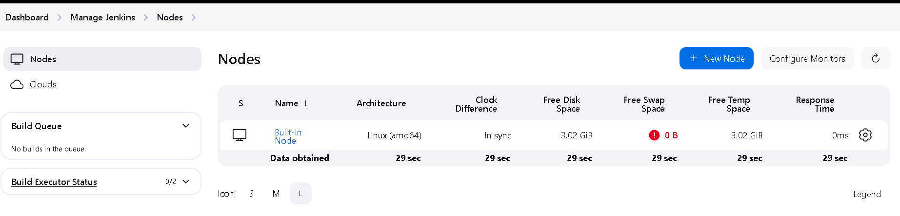
And give name as kops and click on create button
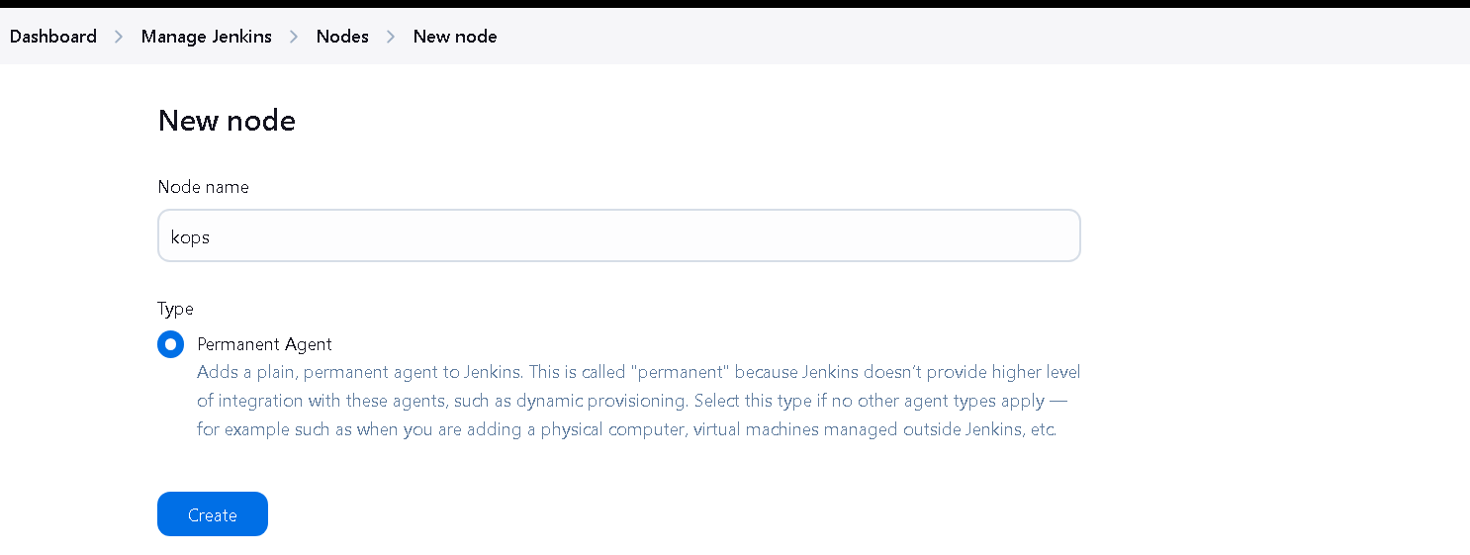
add remote root directory and label
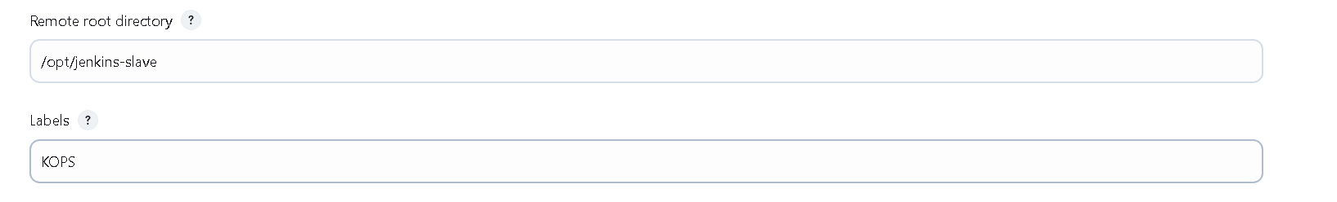
And use below changes
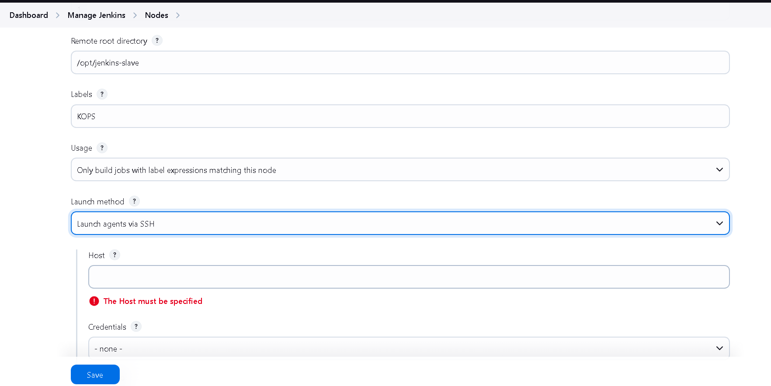
In host add private ip of kops ec2 instance and add credentials of kops ec2 so username will ubuntu and define private key
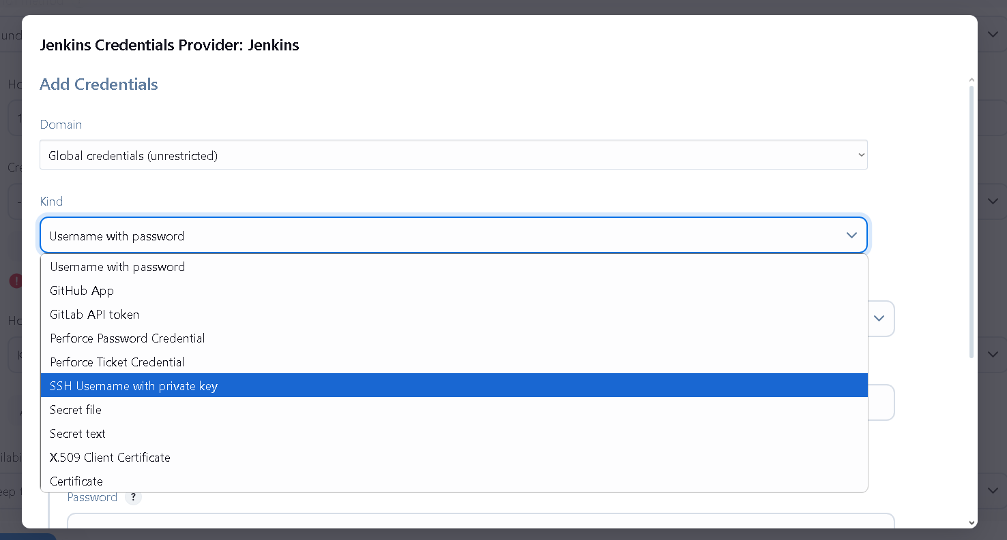
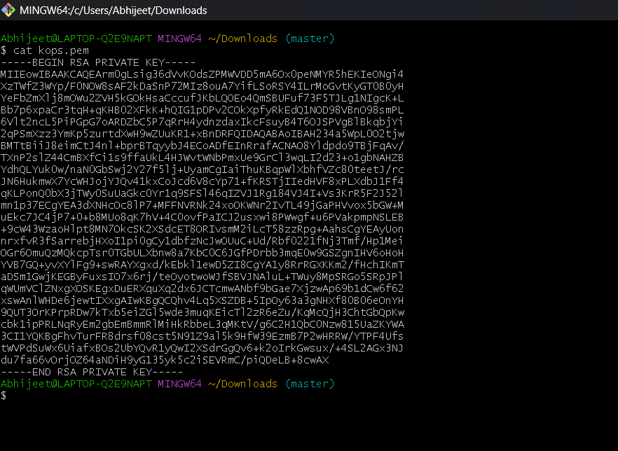

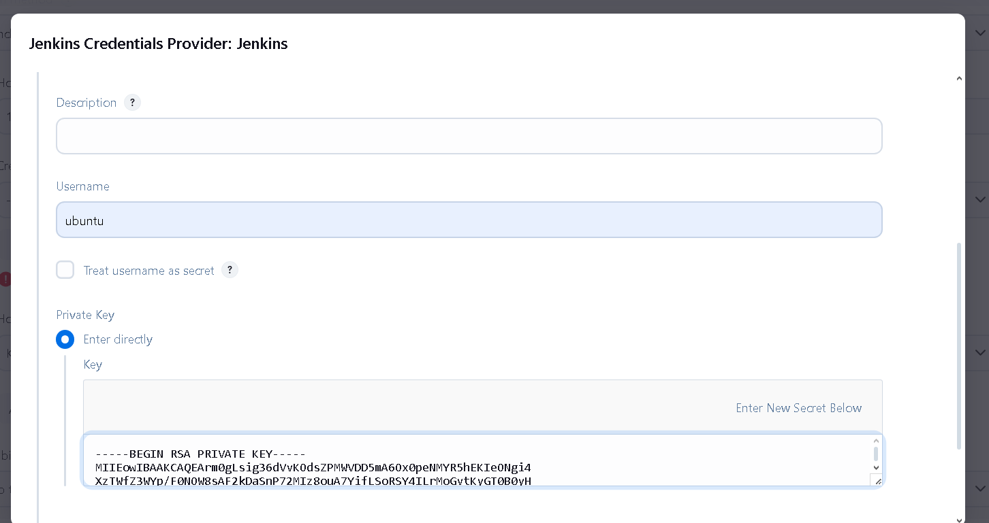

Also set id as kops-login
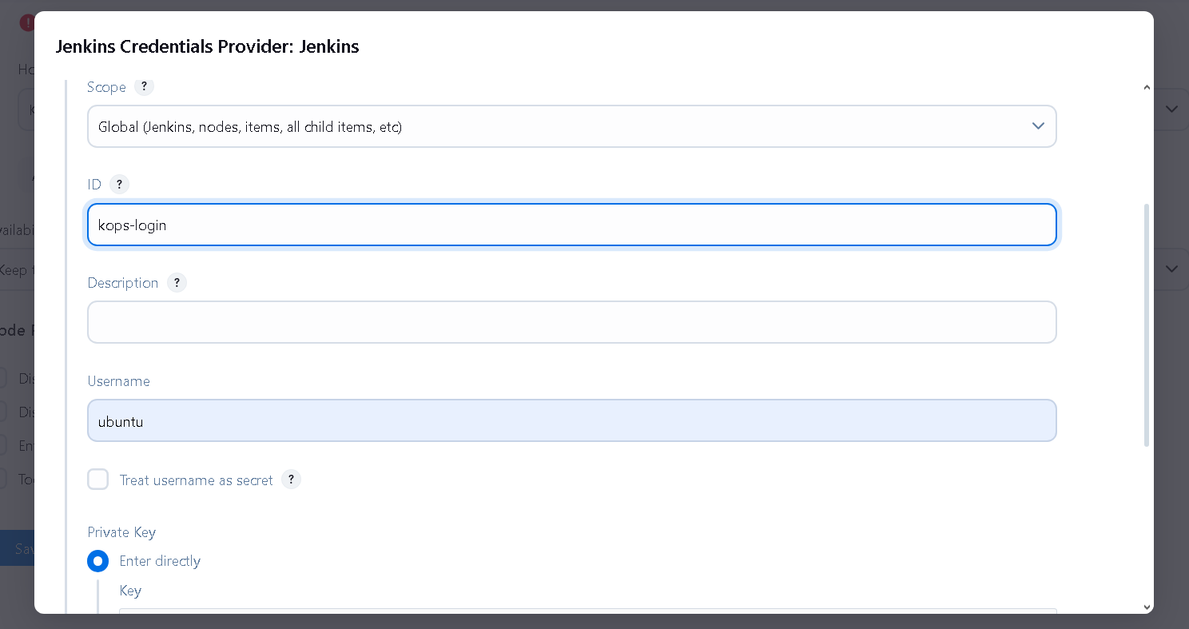

Do not forgot to select ubuntu for credentials before saving and select Non verifying Verification strategy
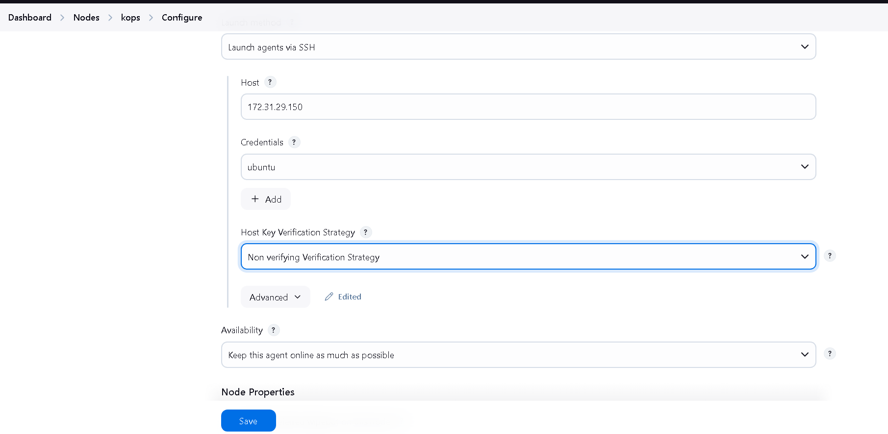

Now here you can see our kops vm successfully added as a slave in Jenkins
